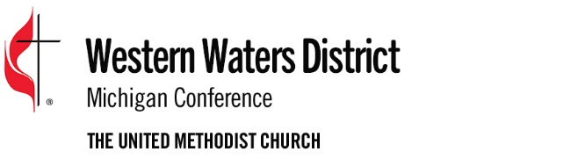
2023 Project Application
Immediate Project Grants
Submission Deadline: Nov. 1

Date of Application _________________ Project Begins _______________

Has this project received (MW or NW) district funding prior to this request? YES ___ or NO ___

If YES, please list the year(s) the funding was received: _____________________________

Name of Mission or Ministry Project: _________________________________________

Project Phone ________________ Address _______________________________________

City _______________________________________ State________ Zip_____________

AMOUNT REQUESTED for this Project: $__________________

Name of Person submitting this application: _________________________________________

Phone ________________________ Email ____________________________________

Is your church up-to-date paying District and Conference Ministry Shares? YES ___ or NO __
If no, please explain:

ON A SEPARATE PAGE, PLEASE THOROUGHLY DESCRIBE YOUR PROJECT:

Does this ministry address the needs and hopes of people in the community? Describe the process you used to determine this.
____________________________________________________________________________
____________________________________________________________________________
____________________________________________________________________________

How are you or your congregation personally willing to invest your very best gifts and abilities to develop this ministry?
____________________________________________________________________________
____________________________________________________________________________
____________________________________________________________________________

List the ministry resources that are currently available and being used:
____________________________________________________________________________
____________________________________________________________________________
____________________________________________________________________________

List other potential assets within the church and among congregation members:
____________________________________________________________________________
____________________________________________________________________________
____________________________________________________________________________
List Potential Partners within your community:
Individuals: ___________________________________________________________________
Businesses: __________________________________________________________________
Associations: _________________________________________________________________
Public Institutions: _____________________________________________________________
Other: _______________________________________________________________________

ON A SEPARATE PAGE, PLEASE ATTACH RESPONSES TO THE FOLLOWING QUESTIONS:
- How does your project fulfill the Mission of The United Methodist Church, “make disciples of Jesus Christ for the transformation of the world?” Please give specific examples.

- How does your project engage in ministry with vulnerable and marginalized individuals and communities? Please give specific examples of how your project:
- Respects the inherent dignity and intrinsic worth of all people engaged in the project?
- Transcends boundaries of race class, social status, etc.?
- Engages in both works of mercy and justice?

PLEASE ATTACH THE FOLLOWING FINANCIAL INFORMATION:
- Proposed budget for project
- Include amount received (or anticipated) from other United Methodist sources
- Amount received (or anticipated) from non-United Methodist sources
- If you envision this project to be ongoing, how do you plan to generate the support necessary to continue?

PLEASE ATTACH THE FOLLOWING INFORMATION, IF APPLICABLE OR AVAILABLE:
- How long has your project been in operation or when do you anticipate it to begin?
- Please attach a roster of the Leadership Team for the project

Please attach an Annual Report, brochures or any other publications describing the work of your project. Priority will be given to collaborative projects and projects where the local church Western Waters District Ministry Shares are paid to date.

Signature of Applicant: _______________________________________________________

Signature of Pastor: __________________________________________________________

Please snail/mail OR scan/email your information packet to:

Western Waters District Office OR
Attention: Liz Bode lbode@michiganumc.org
207 Fulton Street E. Suite 6
Grand Rapids, MI 49503

